16 - 09 Feb 2023 (Kubernetes)

09 February 2023

20:37

Agenda:



# Understanding so far

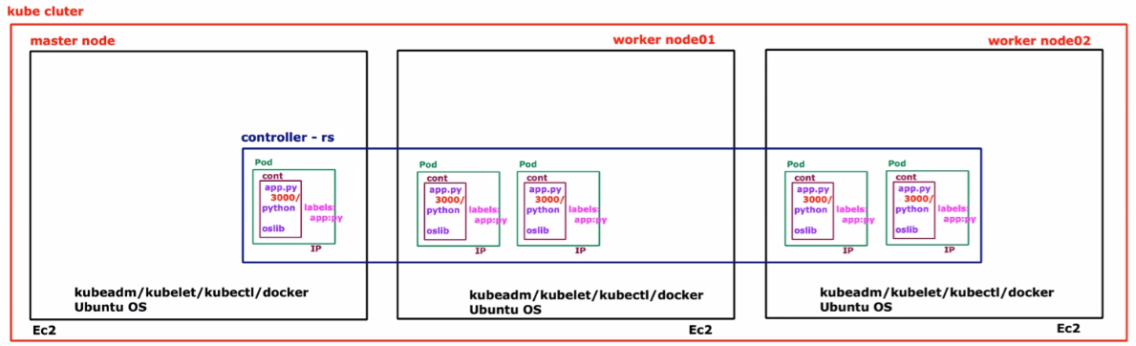

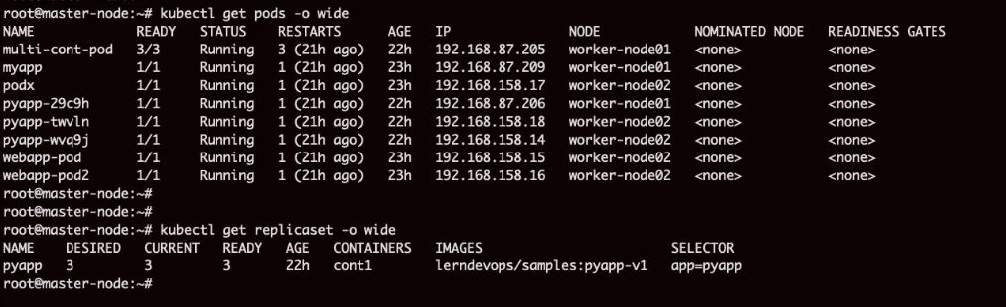

# How to access application?

We have not published any port number.

We must do port-forwarding/publishing.

IP col shows unique IP of each pod.

Pass a command



We use load balancer to use port forward. Load balancer is a must.

Purpose is to have single URL to access these apps

# We use Kubernetes Service to achieve this purpose

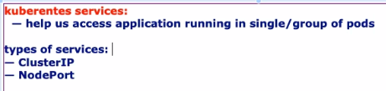

Service.yaml file

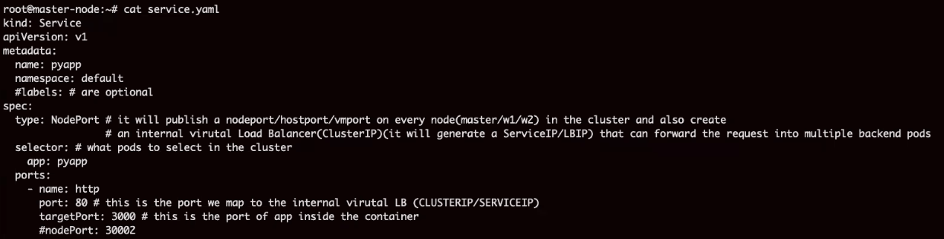

31731 port is published. It is common across all the pods

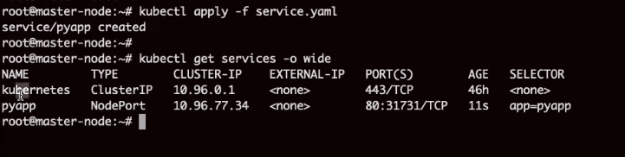

Logically



From Browser



<http://18.116.23.66:31731/>

Just refresh the browser



Cluster IP is working as load balancer

It is dynamic value

Having port number 80

Req from browser to Node -->

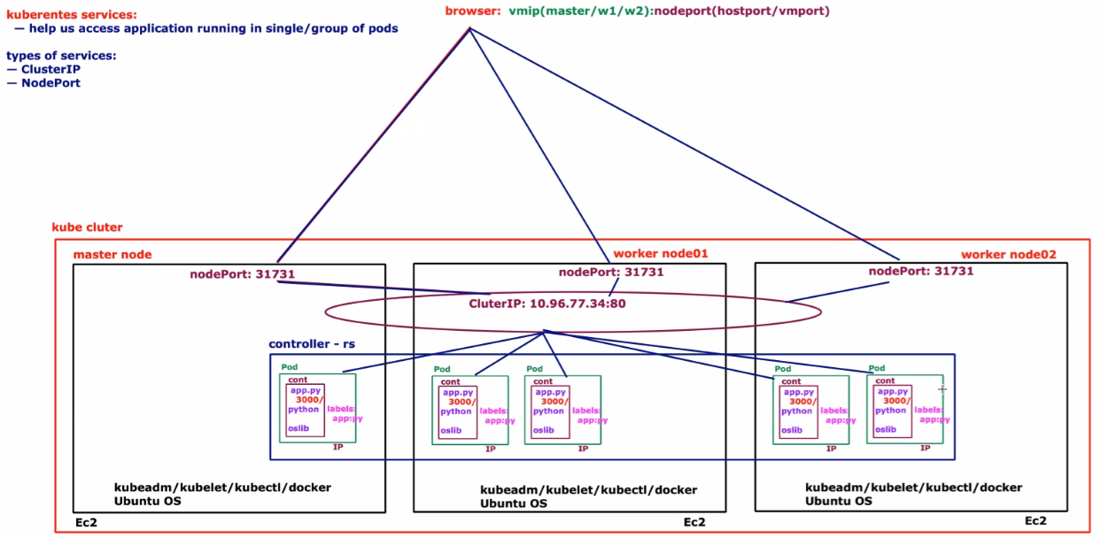

Individual endpoint and port number

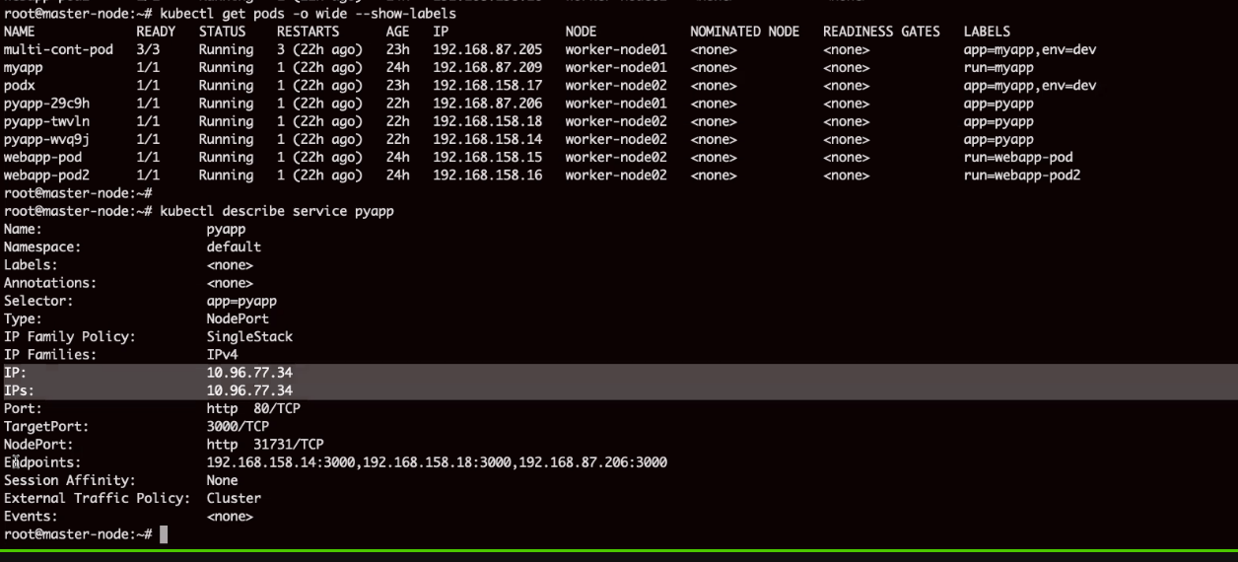

**When to use nodeport and when to use cluster ip**

Web server to be conneted via internet, it should have nodeport

DB server which is internal, should not be exposed to internet, use cluster ip only

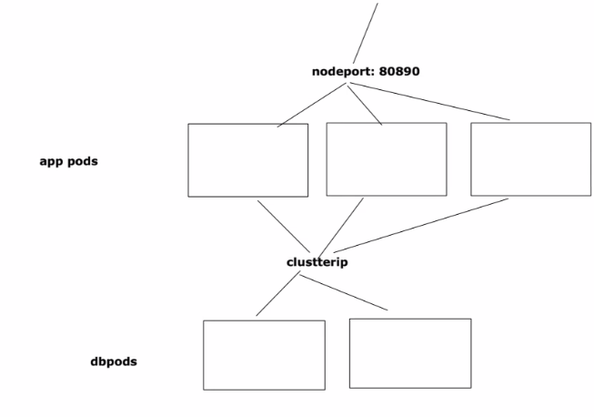

We need external load balancer to map DNS name with nodeport IP

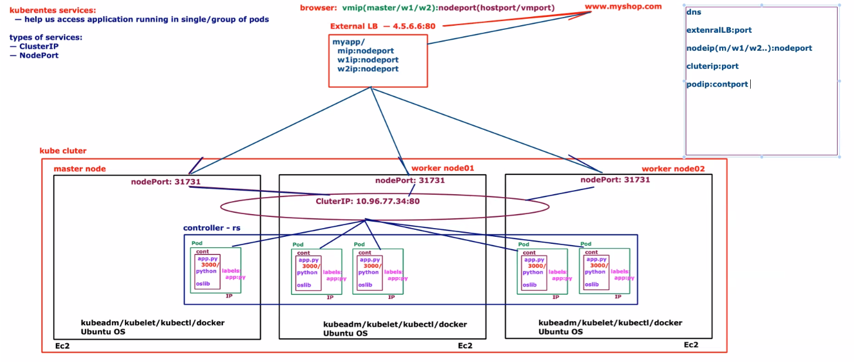

Replicaset controller

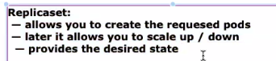

After deletion only controller controlled pods will be recreated

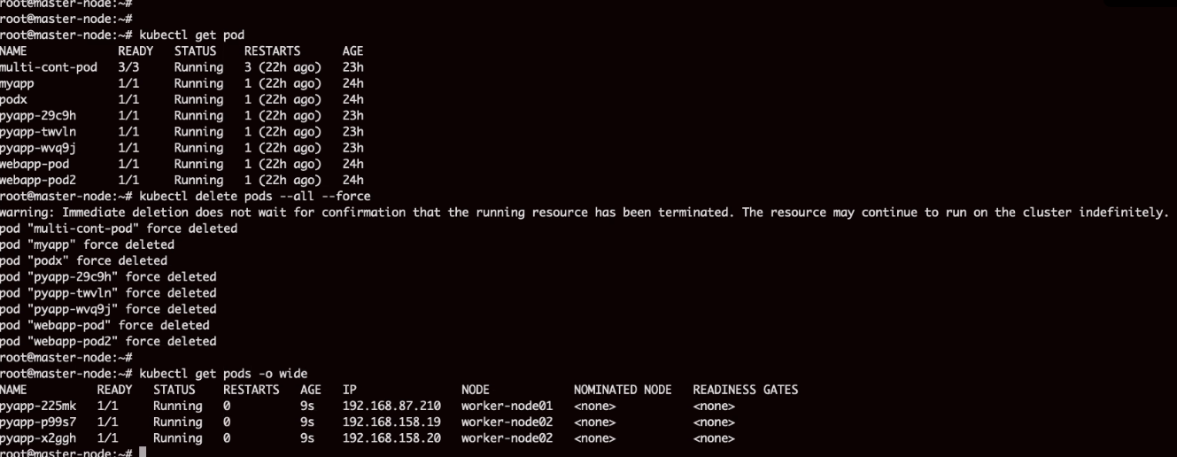

DeamonSet Controller

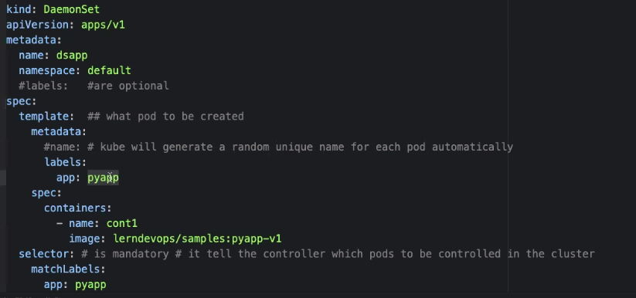

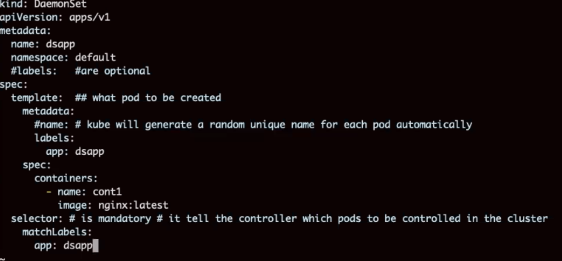

It created 2 nodes because there are 2 worker nodes

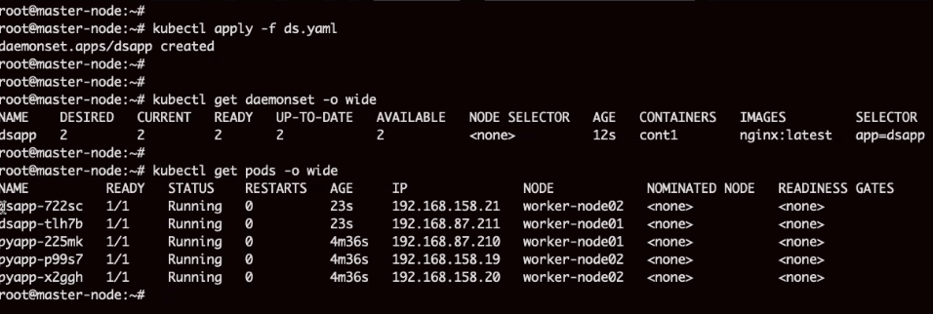

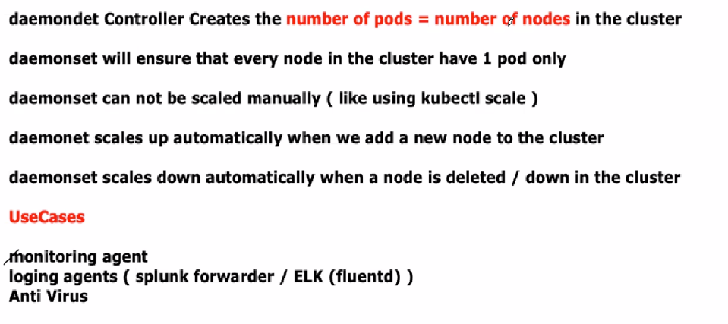

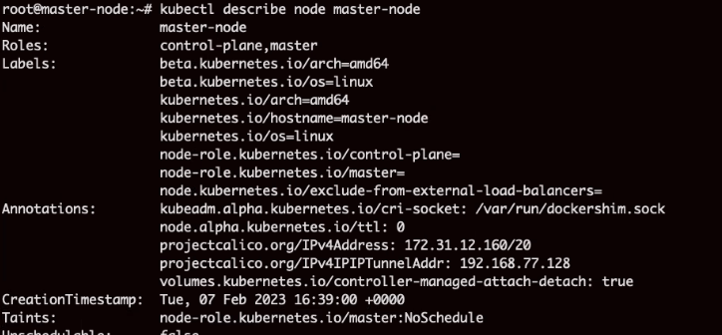

**DEPLOYMENT CONTROLLER**

**Deploy application without downtime**

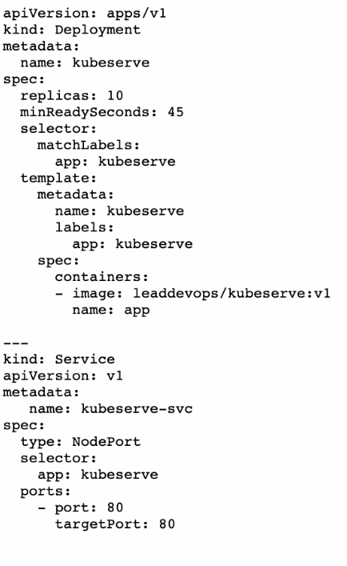

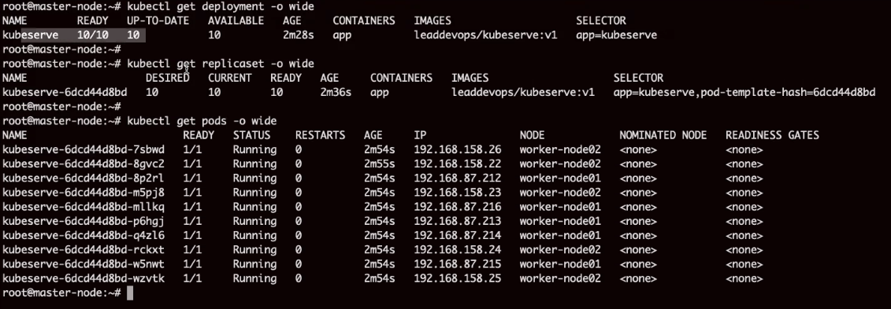

Updated versiont o v2 in yaml file

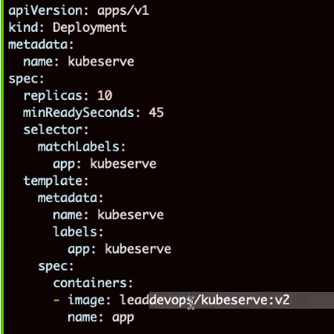

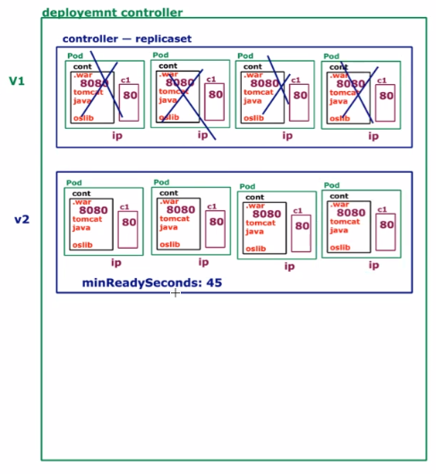

Loop

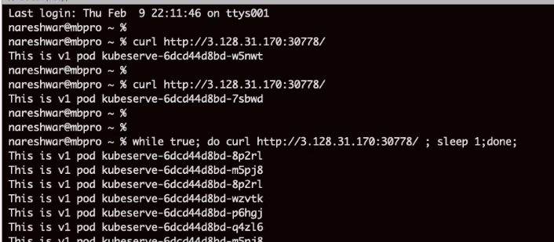

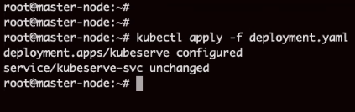

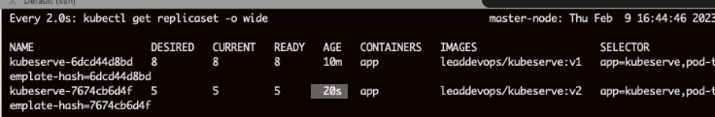

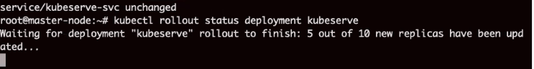

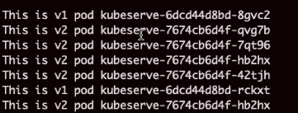

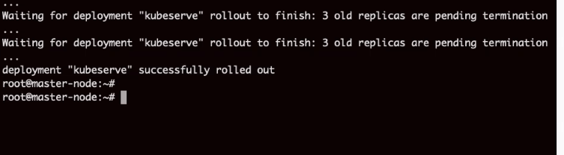

Rollback

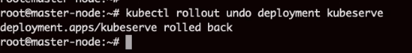

History

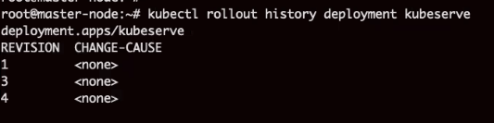

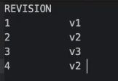

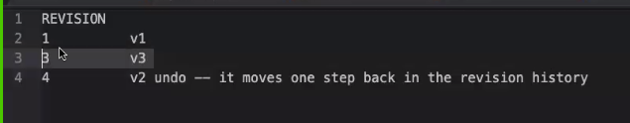

Move back to rev 1

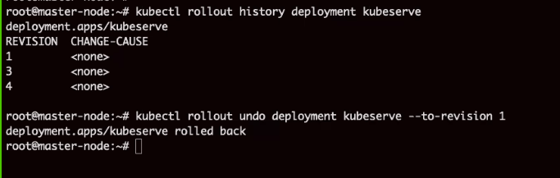



17 - 10 Feb 2023 (Kubernetes - Volume)

10 February 2023

20:41

**Agenda:**

Volumes

Config map

secrets

# Kubernetes Volumes:

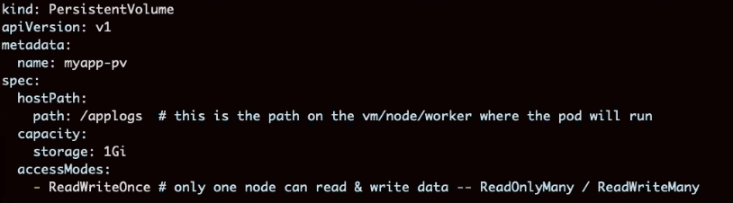

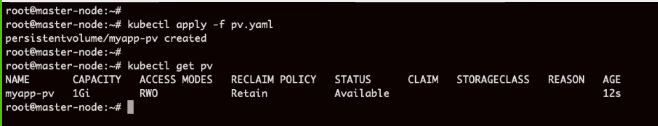

Status is available.

All app can write data in this volume. This will create a mess.

In kube pv cannot be access by pod directly because of kube's policy.

We must create a pvc & point to pv.

Pvc - persistent volume claim

Pv - persistent volume

Example:

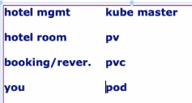

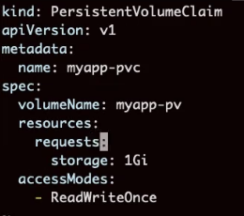

Pvc Status is bound

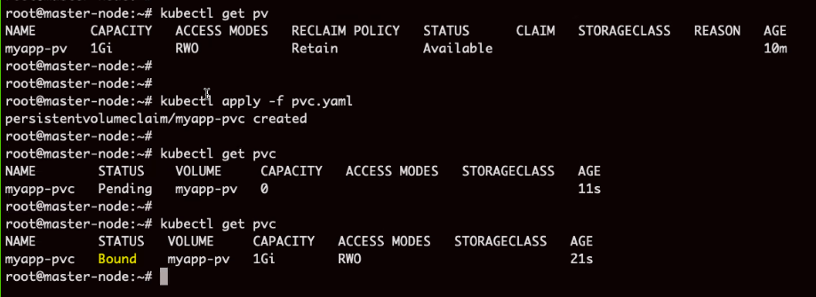

Pv Status is bound



Pvc is for pod, in order to allow access to container it will have to mount the volume

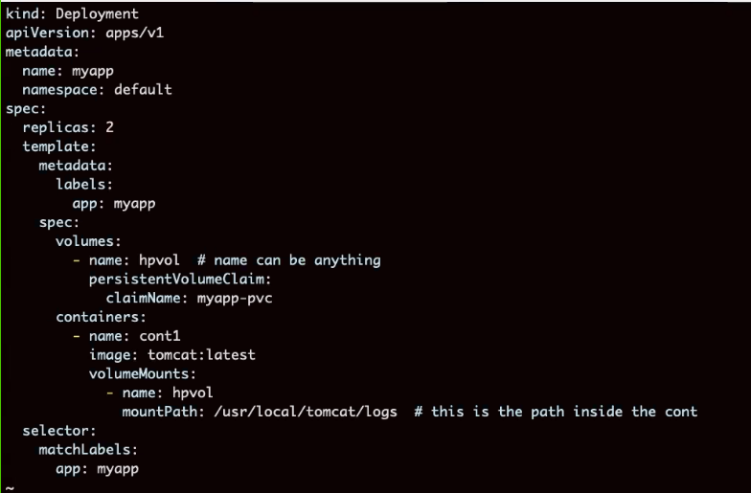

Pod is creted in worker node 1 and 2

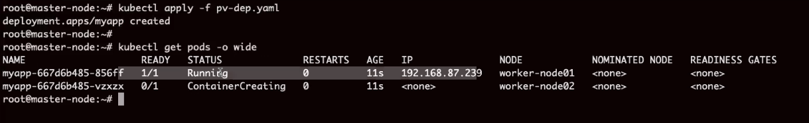

Go to worker node 1

Data will be visible on node1 and inside container as well. Because is mount drive

Cd /applogs

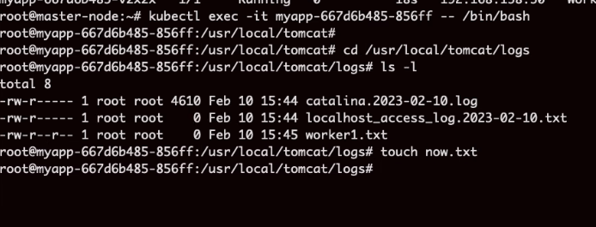

# ConfigMap

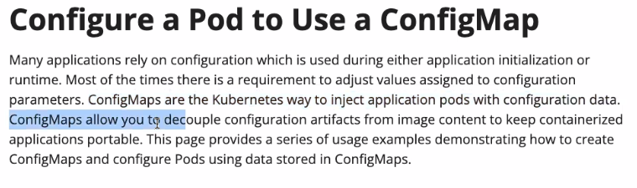

Db.props

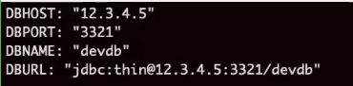

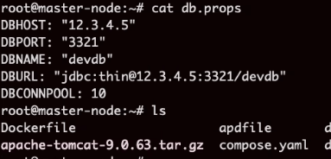



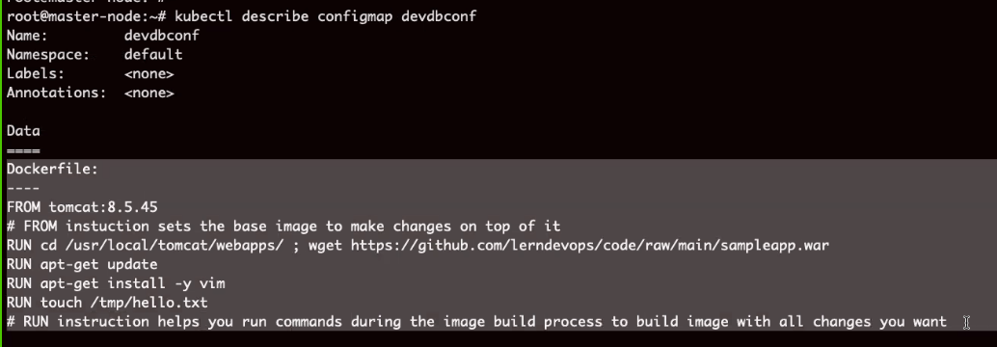

New file

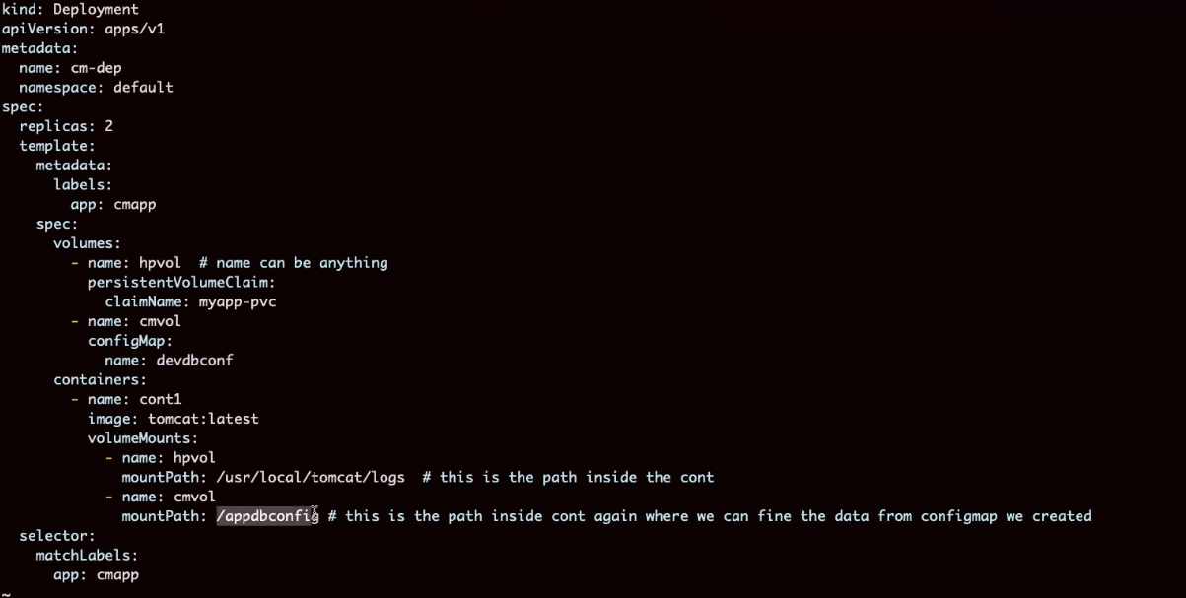



Historuy:

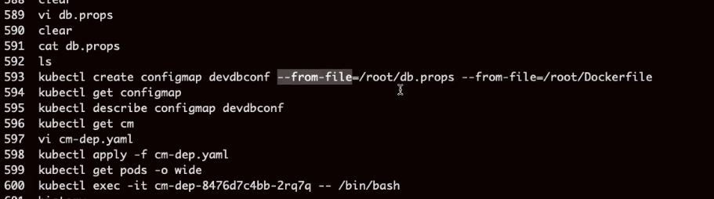

# Secret

Store password and config values

Config map is not recommended

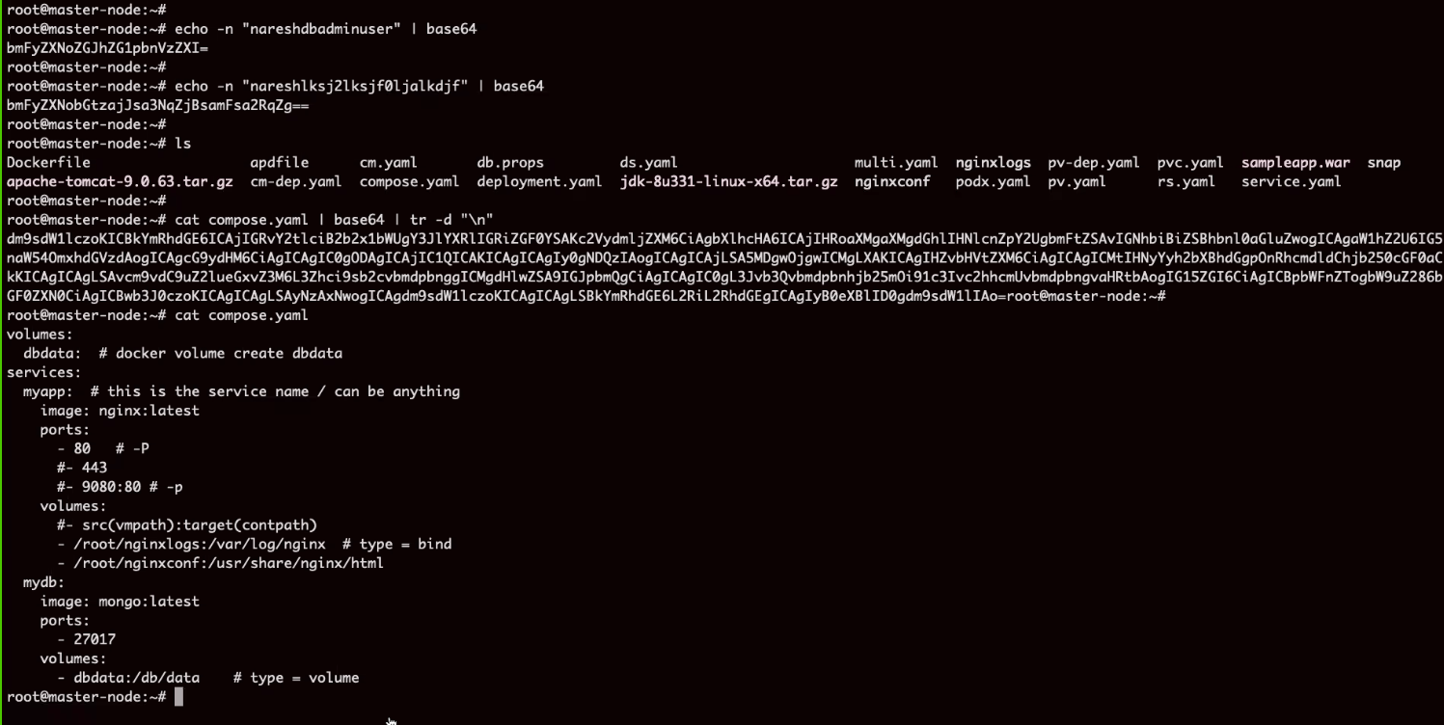

**Can be done via YAML**

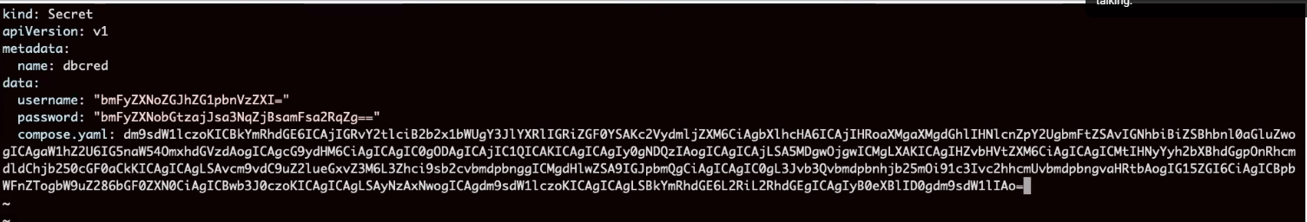

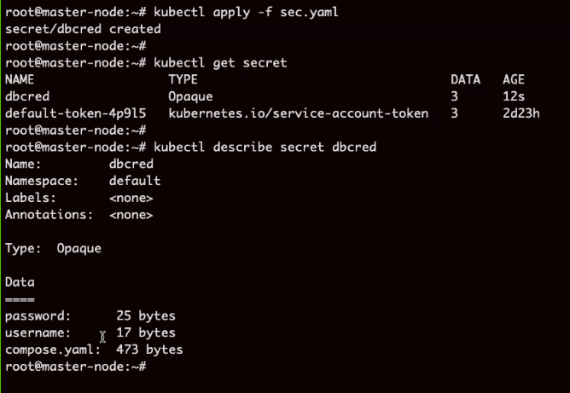

**Modified previous code, added secret at runtime**

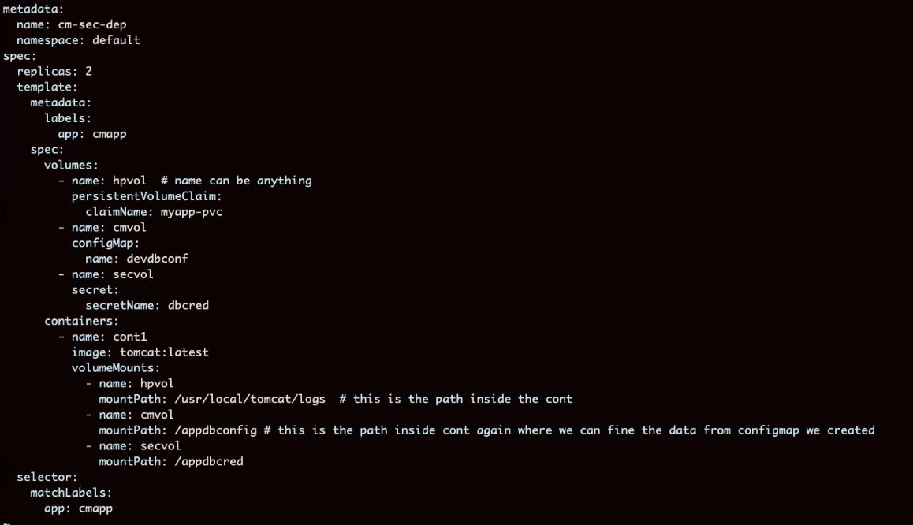

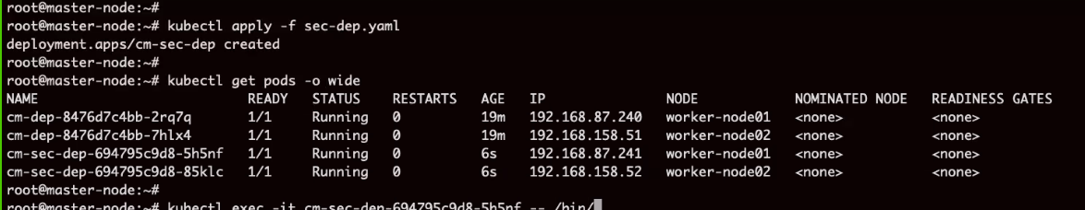

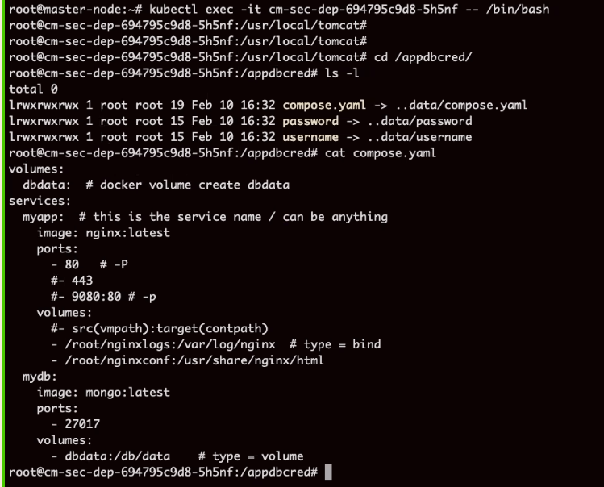

**Dashboard**

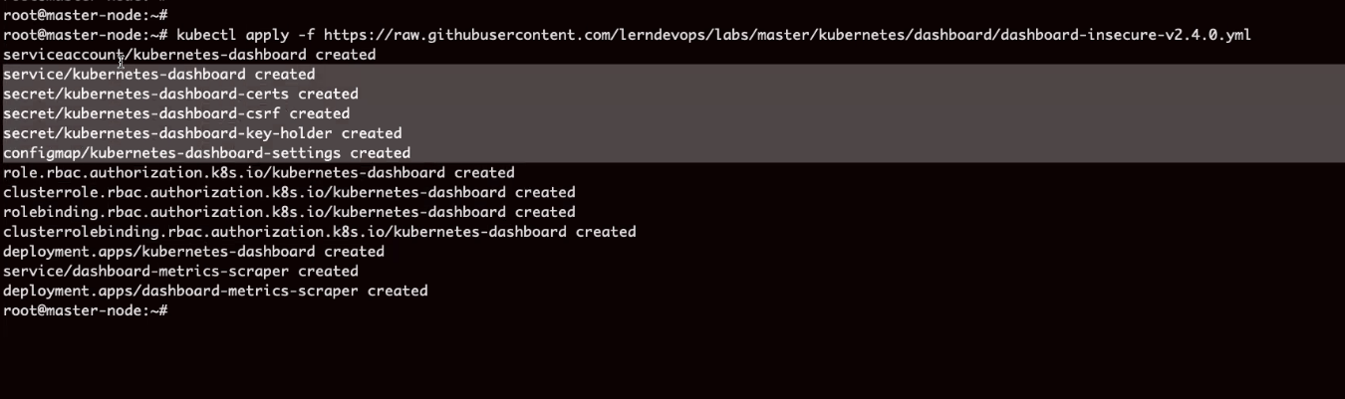

A service is created with port number

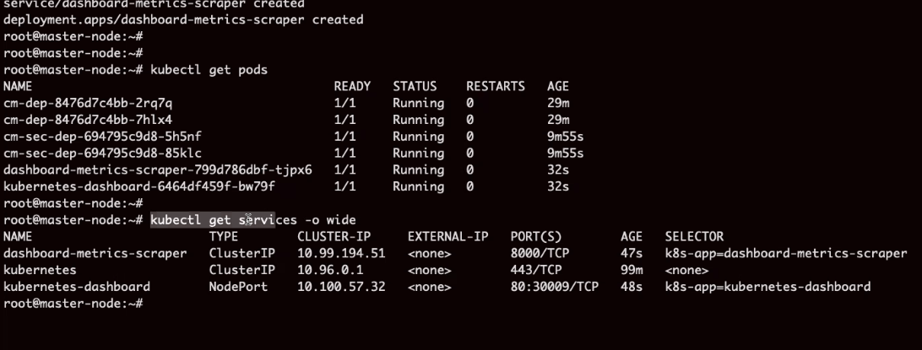

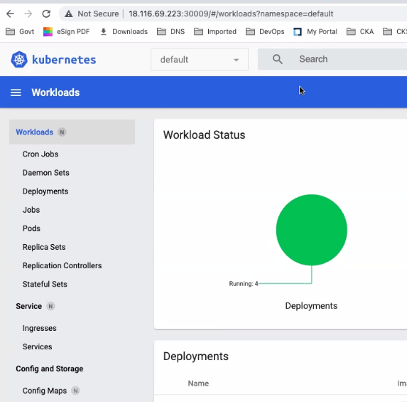



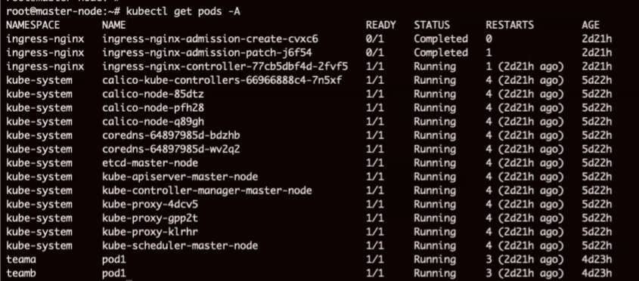

# What is ingress

It is about accessing application within kube cluster.

Current example is about on application for which we created one LB.

What if we have 10 apps, should we create 10 LBs?

Answer is NO. we use ingress here.

Ingress controller is a load balancer which helps forward request internally without a LB.

<https://github.com/lerndevops/labs/tree/master/kubernetes/ingress>

|  |
| --- |
| **Ingress**  An API object that manages external access to the services in a cluster, typically HTTP, Ingress can also provide load balancing, SSL termination and name-based virtual hosting  Ingress exposes HTTP and HTTPS routes from outside the cluster to services within the cluster. Traffic routing is controlled by rules defined on the Ingress resource  **Deploy three different Apps on k8s cluster**  <https://raw.githubusercontent.com/lerndevops/educka/master/6-networking/ingress/deploy-app.yml>  **Deploy Ingress Controller**  kubectl apply -f <https://raw.githubusercontent.com/kubernetes/ingress-nginx/controller-v1.3.0/deploy/static/provider/baremetal/deploy.yaml>  **Deploy Ingress Resource(rules)**  kubectl apply -f <https://raw.githubusercontent.com/lerndevops/educka/master/6-networking/ingress/ingress-rule1.yml>  **Get Ingress Controller Service NodePort**  get Ingress Controller Pod NodeIP & Ingress Controller Service NodePort  kubectl get pods -n ingress-nginx -o wide ## Note the Node IP in which the Ingress Controller Pod is Running  kubectl get services -n ingress-nginx ## Note the Ingress Servcie NodePort  **validate**  From the above details noted in your browser hit as below    masterNodeIp:NodePort/app1  worker1NodeIp:NodePort/app2  worker2NodeIp:NodePort/app3    Example: 192.168.198.129:30528/app1, 192.168.198.129:30528/app2, 192.168.198.129:30528/app3    From <[*https://github.com/lerndevops/labs/tree/master/kubernetes/ingress*](https://github.com/lerndevops/labs/tree/master/kubernetes/ingress)> |

<https://raw.githubusercontent.com/lerndevops/educka/master/6-networking/ingress/deploy-app.yml>

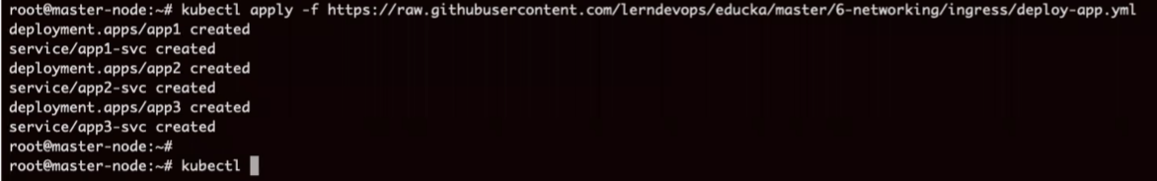

3 services created

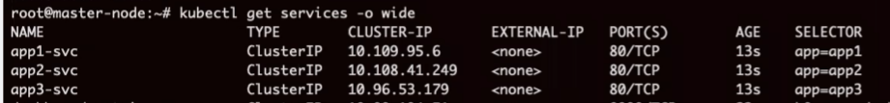

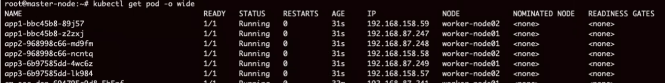

How to access these services internally

Create a load balancer within cluster with ingress congroller



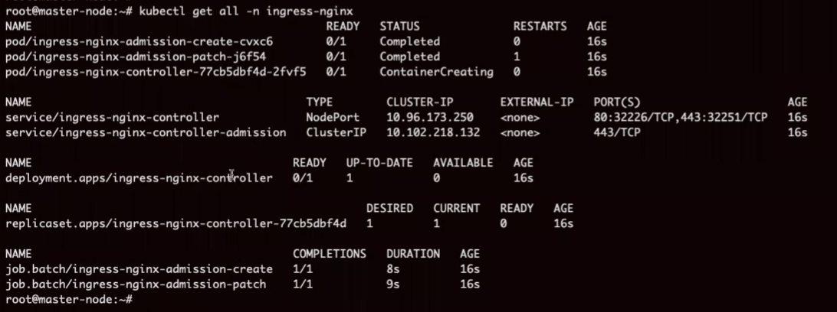

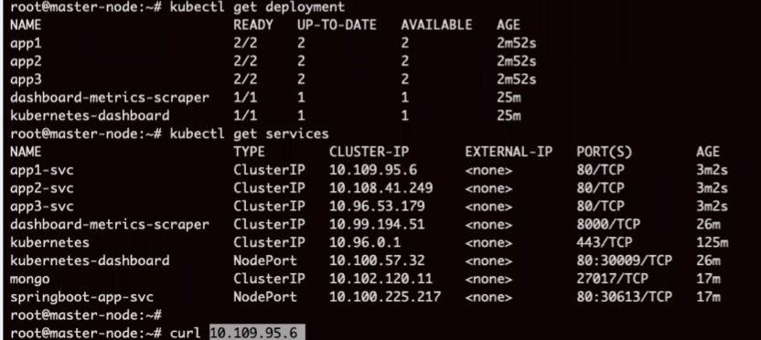

Current state



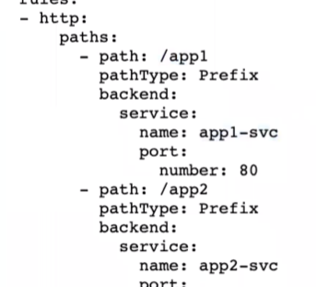

Adding traffic route



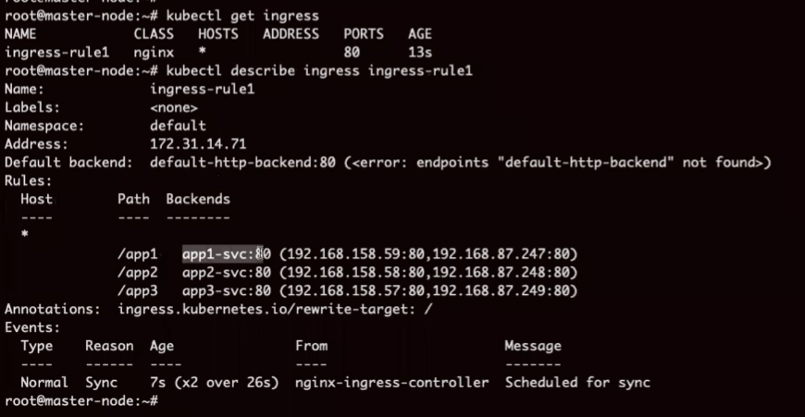

Checck IP below and route above

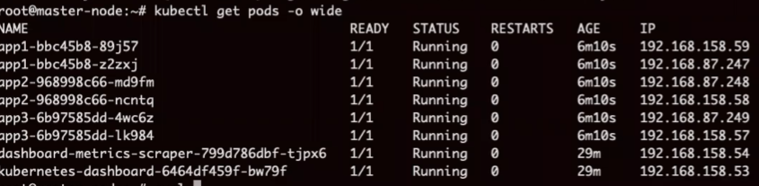

Now

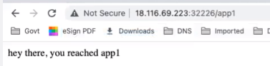

Ingress is enabling additional routing sitting within cluster.

This is how it works

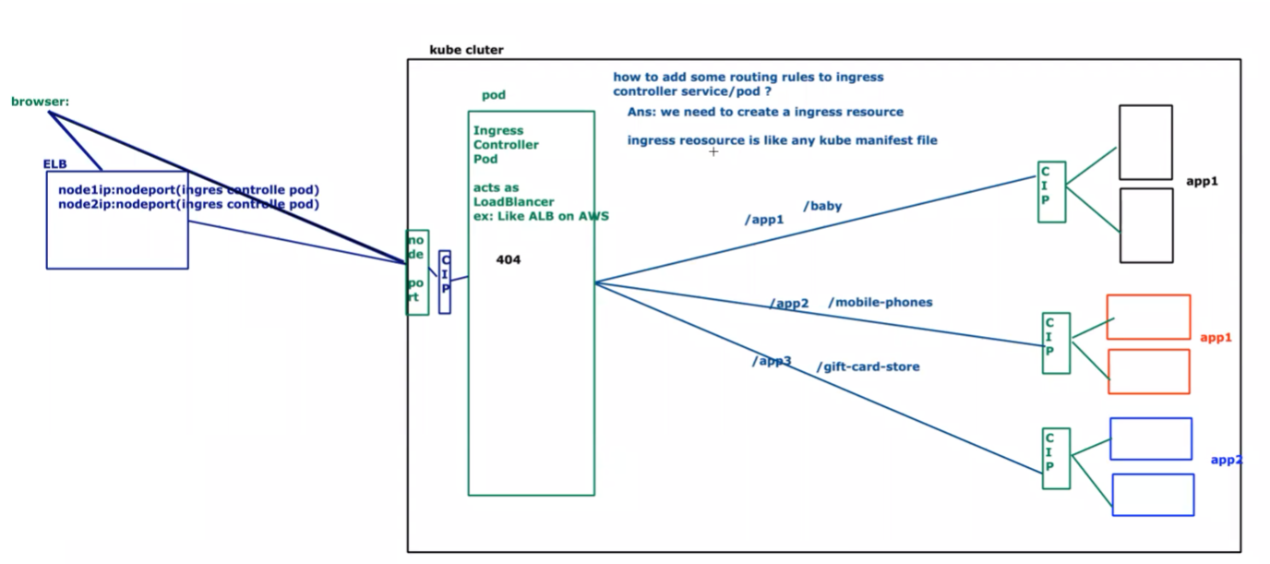

Example:



# 